NAME: ALABI DAVID TOLULOPE
NICKNAME: CYBERDAVE
GMAIL: alabidavid2023@gmail.com
PROJECT: NETWORK TRAFFIC ANALYSIS USING WIRESHARK

Objectives: Capture and analyze network traffic

Tasks: Capture packets on your network, Identify HTTP, HTTPS, DNS, and ICMP traffic, detect suspicious connections, create a report explaining your findings.

Solution:
- Capture packets on your network: I opened my Wireshark application on my Windows, allowing it to run for some minutes (5-10 minutes) while my browser is fully loaded with websites of different protocols (Http, Https). I went to the command terminal on my Host machine to ping the dns named www.google.com in-other for my Wireshark to capture the ICMP traffic while running. This is the outcome:

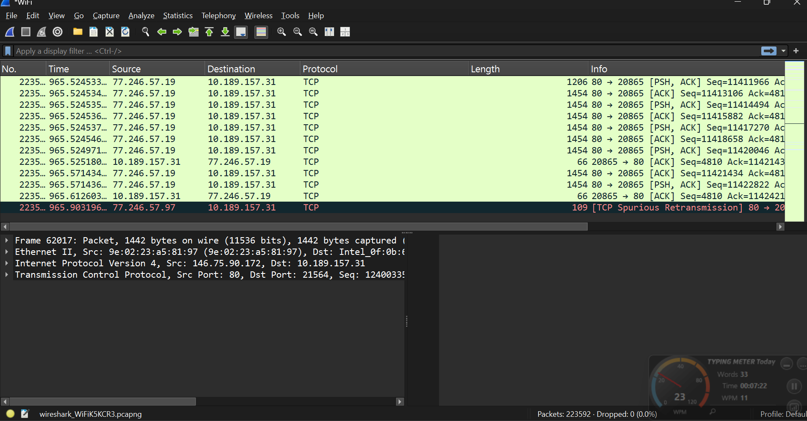

- Identify HTTP, HTTPs, ICMP and DNS traffic
- HTTP:
- I filtered http on the filtered bar
- I looked for the GET request, POST request, Websites URLs and User-Agent Information
- Under the Http, the result show that there is no encryption for the protocol. All texts are shown in a plain text but not in a cipher text which made it a very easy to be sniffed by an attacker. I observed that all my login credentials are exposed plainly in it and this mean anyone can have all my credentials without my consent.
- This little network traffic reveals that http isn’t a protocol to use.

- 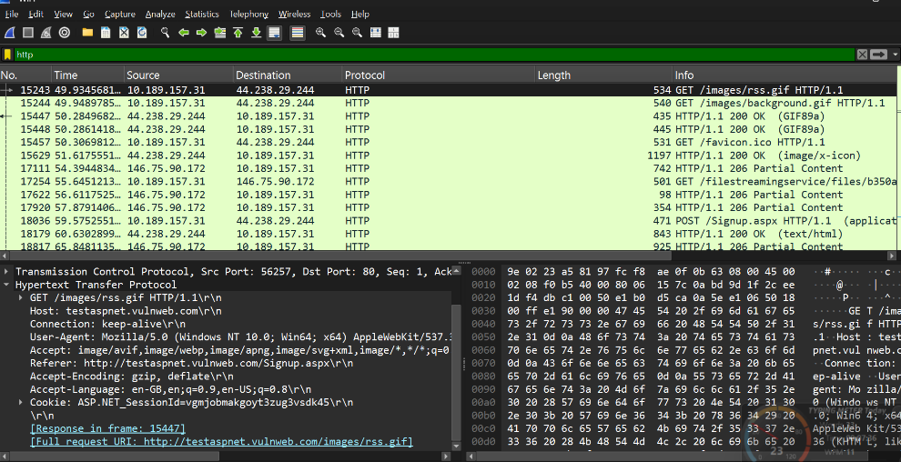
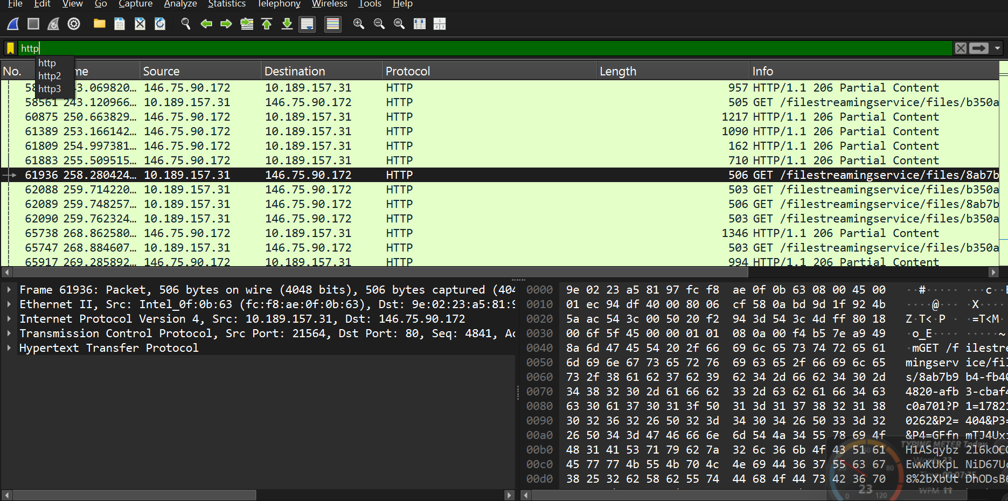

- HTTPs:
- I filtered https on the filtered bar.
- I looked for the TLS handshake, Client Hello, Server Hello and encrypted application data.
- I looked into them by clicking on each traffics, checking its connection and analyzing them.
- I found out that all packets are encrypted with AES 256 Encryption, making it difficult to read. My details aren’t written in a plain text but in a secret-codes.

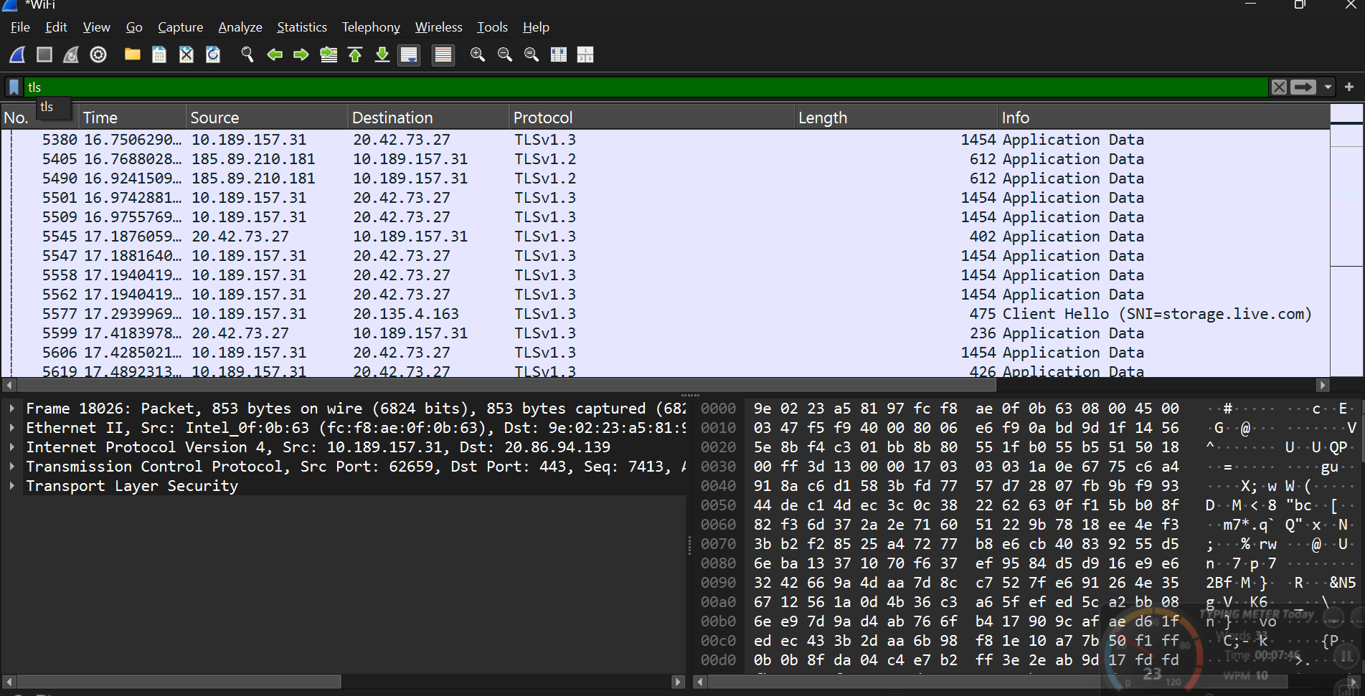

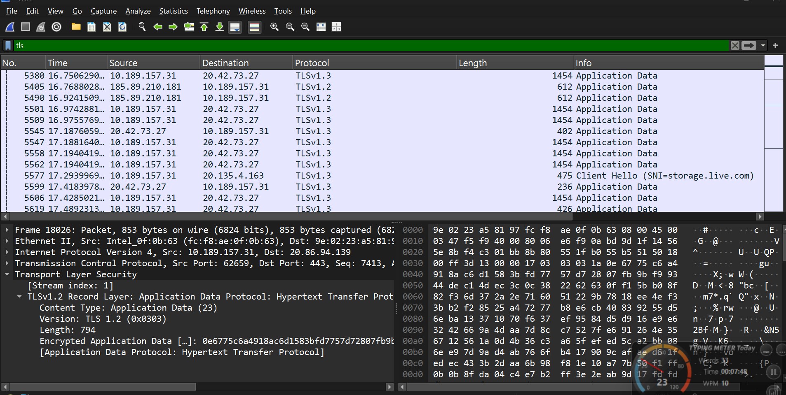

- DNS: I filtered the bar with the domain name server looking for DNS Queries, DNS Response.
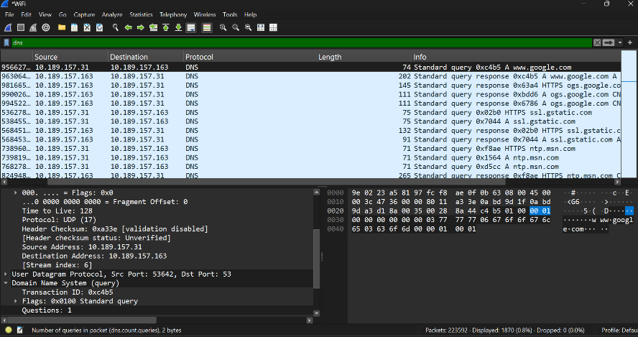

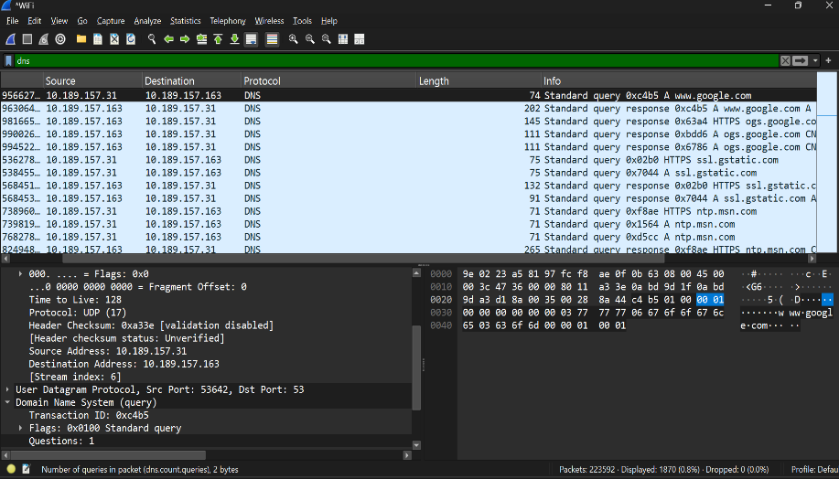

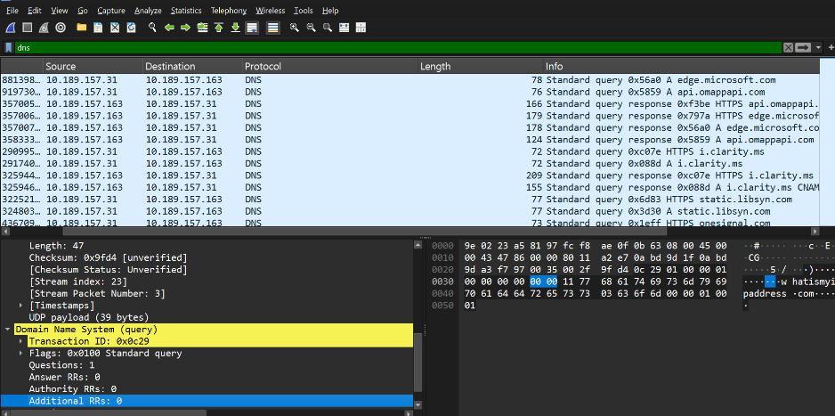

- ICMP: I generated ICMP Traffic by opening a terminal and I ran a command in it (Ping google.com). While my Wireshark is running, it captured the ICMP Traffic with the evidence of looking for an echo request or echo reply.

